**Ex:** 13

**Date:** 20/11/2020

**Aim:**

Creating a python program to calculate a product’s price with conditions.

**Program:**

class Apparel:

counter=100

def __init__(self,price,itemtype):

Apparel.counter+=1

self.itemid=itemtype[0]+str(Apparel.counter)

self.iprice=price

self.itype=itemtype

def calc_price(self):

self.iprice+=self.iprice*0.05

def get_itemid(self):

return self.itemid

def get_itype(self):

return self.itype

def get_price(self):

return self.iprice

def set_price(self,price):

self.iprice=price

return self.iprice

class Cotton(Apparel):

def __init__(self,price,discount):

super().__init__(price,'Cotton')

self.idiscount=d

def get_discount(self):

return self.idiscount

def calc_price(self):

super().calc_price()

price=self.get_price()

price-=price*(self.idiscount/100)

price+=price*0.05

self.set_price(price)

return price

class Silk(Apparel):

def __init__(self,price):

super().__init__(price,'Silk')

self.ipoints=None

def getipoints(self):

return self.ipoints

def calc_price(self):

super().calc_price()

if(self.get_price()>10000):

self.ipoints=10

else:

self.ipoints=3

return self.set_price(self.get_price()+(self.get_price()*0.1))

s=int(input())

c=int(input())

d=int(input())

a=Silk(s)

print(a.calc_price())

b=Cotton(c,d)

print(b.calc_price())

**Output:**

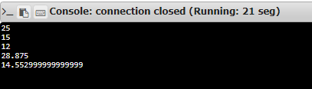

**Result:**

Thus, creating a python program to act as shop with given conditions is done.

**Link:**

<http://103.53.53.18/mod/vpl/forms/submissionview.php?id=328&userid=1652>